My strategy – trading EA strategy

Bull to bearish –

Bearish to bull –

* Entry is marked as **green** on screen shots
* Exis is marked as red

**Condition for entry**

* Market breaks through the outer bands and triggers our entry point which will be 50-100pips above the outer bands.
* Stop loss is 100 pips if the price hits our stop loss and on its way up/down and its still out of the outer band the ea will be triggered again to trade.

For example on picture once the priced reached the triggering point we would’ve entered but we would’ve been stop out. But as the market comes back down its still above the outer ring and its hit that 180-100 pip zone we will renter again the same trade.

**Condition for Exit –**

* Exist once the market reaches the inner bands of the trade’s direction. This allows for the trading to have greater
* 2 - The take profit will only be fixed to the other inner bands
* So this way the market can be follow until the condition has been achieved.

**EA OPTIONS TO**

* To choose pip levels for stoploss or trail stop option.
* How many pips from the outer bands to entry points. Usually between 0-150 pips depending on what I am trading etc.
* Change the timeline to operate on either 1minuet, 5 minutes, 1.30 or 1hr or on the daily depending on the assets I am trading.

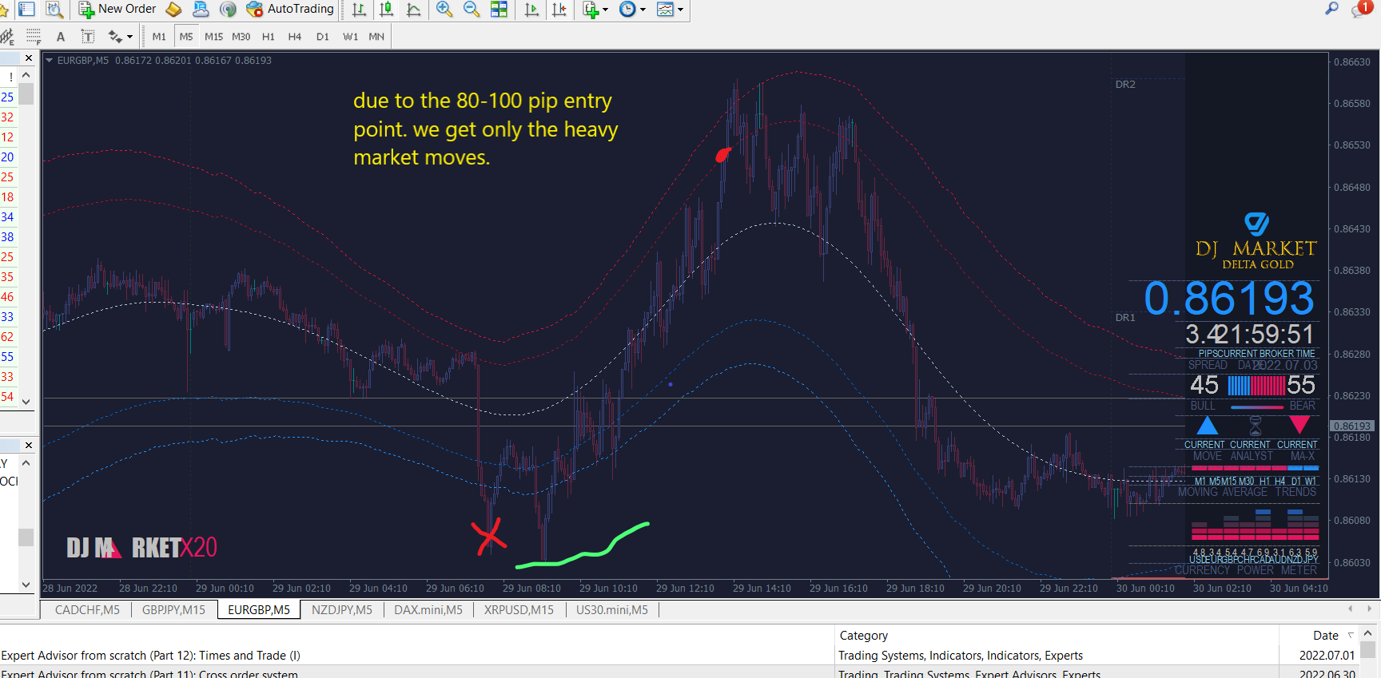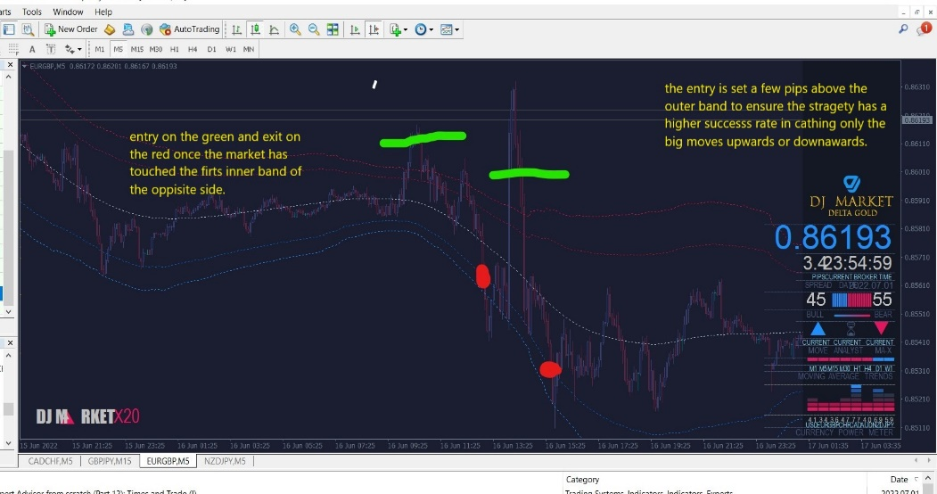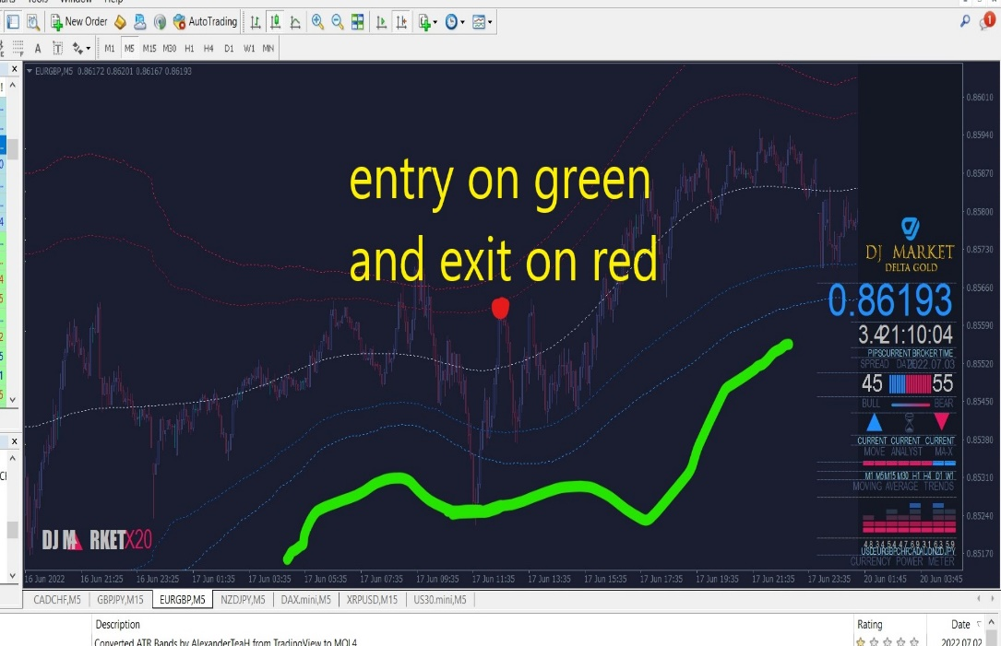I want the ea. to able to use the perimeters used by this custom indicator to determine entry / exist point for strong market moves.

**IDEAS TO THAT COULD HELP**

By using/ creating editable bands which could be used with the EA for entry. These bands would have optional edit for how close their to the outer bands by pips 0 would mean that that flash/right next to the outer bands for either buy or sale options. based on the strategy and asset which is being dealt with in that moment the distance can be increased or decreased by pips so 10 pips apart from outer bands to 200pips apart from the outer band.